MView Manual
Noah Meltzer

What is MView?
At the highest level, MView is a framework that can be used to interface with virtually any external data source. In short, MView takes care of the overhead involved with running a GUI and device communication so that the end user can concentrate on their data.
Using MView, a variety of control and display elements can be easily configured. These include:
- Buttons
- Numerical/Textual Readouts
- Plots
In addition, some backend features include:
- Datalogging using Datachest
- Email/Text notifications
- Logic
MView accomplishes this by wrapping low-level communication and overhead into a device driver that abstracts all sources of data (devices) into an MDevice object. All MDevice objects implement a common software interface. This allows even the most complex devices to be handled in a simple manner.
With this system in place, MView implements a range of error-checking, graphing, and logging functionality which the end user can use with ease.
While not nearly as powerful as LabVIEW, MView is easy to set up and it works. This makes it ideal for simple monitoring tasks where the massive overhead of LabView is not needed. Additionally MView is also accessible by anyone who knows even the smallest amount of python without the need to learn G.

The MView Interface

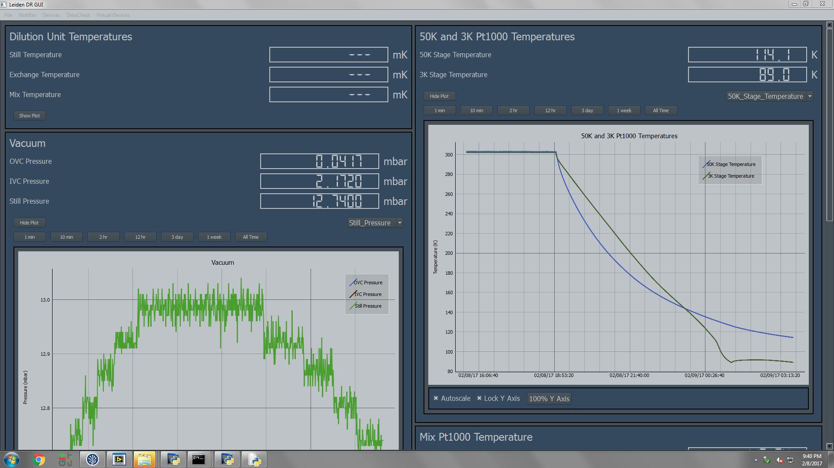
Plot
Parameters
Device Tile

MView for Our Purposes

Setting up a simple GUI for LabRad Devices
Setting up a new MView GUI is generally very easy. In this section, we will configure a simple MView project that monitors data from a LabRad device.
In order to create a GUI using MView, we must set up a program that configures our devices and tells MView how to behave. This is done below.

Before You start:
- Please refer to the DataChest manual for DataChest setup.
- Please refer to the comments in telecomm.py for telecomm server setup.

Step 1: Imports
The first thing that must be done is to import the necessary MView libraries.
import MGui # Handles all GUI operations. Independent of LabRAD.
from MDevices.Device import Device # This is the device driver that represents a LabRad server

MGui: Handles the overhead of initializing MView
MDevices.Device: All device drivers are stored in the MDevices folder. Device is the device driver that talks to LabRad servers.

Step 2: Initialization
Next, we need to write the class that initializes MView as well as all Devices.
class MyGuiClass:
my_gui = None
my_devices =[]

my_gui: Will hold a reference to the MVeiw Gui.
my_devices: Will hold the list of devices.

Step 3: Create a LabRad and Telecomm Server Connection
A connection to LabRad is created so that it can be passed to devices.
try:
# Attempt to establish a labrad connection.
cxn = labrad.connect()
except:
# If no connection can be made, abort with an error message.
print("Please start the LabRAD manager")
time.sleep(2)
sys.exit(0)
try:
# As of writing, there is one class in MView itself that is dependent
# on LabRad, and it requires the telecomm server to be running.
# This is subject to change.
tele = cxn.telecomm_server
except:
# If no connection can be made, abort with an error message.
print("Please start the telecomm server")
time.sleep(2)
sys.exit(1)

NOTE: The code in steps 1-3 is the same for all MView GUIs.

Step 4: Initializing Devices

A) Instantiating a new device
We must now initialize the LabRad Devices. Let’s create a device that represents a CP2800 compressor.
First, we instantiate a new Device:
Compressor = Device("Compressor")

This creates a device called “Compressor.” Not much else happens until we tell it how to communicate.
Second, we pass it a reference to our connection:
Compressor.connection(cxn)

Third, we tell it what the name of the server is. The name of the server for the CP2800 is “cp2800_compressor.”
Compressor.setServerName("cp2800_compressor")

B) Adding Buttons
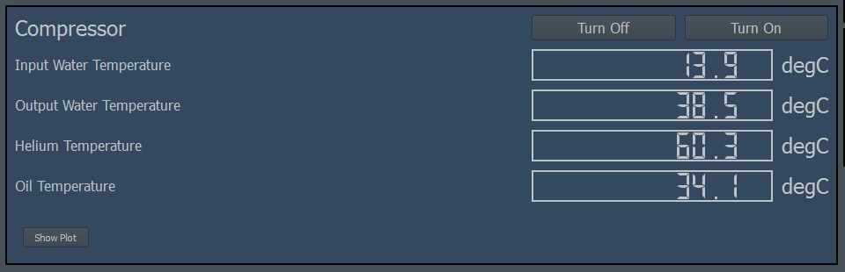

Next, let’s add a button that turns off the compressor when we click it. This is done using the MDevice.addButton(label, message, setting, setting arguments) method.
Compressor.addButton("Turn Off",
"You are about to turn the compressor off.",
"stop", None)
Compressor.addButton("Turn On",
"You are about to turn the compressor on.",
"start", None)

MDevice.addButton(label, message, setting, setting arguments)

Here is how it should look in the context of this example:
The first argument sets the button’s text. The second argument is the text to be displayed in a warning popup, if no warning is to be displayed, then the second argument should be None. The third argument is the LabRad server setting that is triggered when the button is pushed, and the fourth argument is an array of arguments for the LabRad setting, None if no arguments.

C) Adding Parameters

Parameters
It is now time to add parameters to the device’s tile. This is done with the MDevice.addParameter() method.
MDevice.addParameter(Label, LabRad Setting, Arguments, Array Index,
Preferred Units, Readout Precision)

Here is how it should look in the context of this example:
Compressor.addParameter("Input Water Temperature",
"current_temperatures_only", None, 0, 'degC', 1)
Compressor.addParameter("Output Water Temperature",
"current_temperatures_only", None, 1, 'degC', 1)
Compressor.addParameter("Helium Temperature",
"current_temperatures_only", None, 2, 'degC', 1)
Compressor.addParameter("Oil Temperature",
"current_temperatures_only", None, 3, 'degC', 1)

The first argument tells MView what to call the new parameter. The following argument is specific to the LabRad device driver, and it tells MView which LabRad setting to call in order to get the value. Next, are the arguments to be passed to the LabRad setting, they are None in this case, because the setting does not take arguments. This LabRad setting returns a list, and the next numbers are the index in the list where the parameter value can be found. Next are the preferred units. MView will try to use the preferred units. Lastly is the precision (number of decimal places) to be displayed.

Step 5: Selecting the Device
Just as with any LabRad device, we must call the ‘select_device’ command. This is done in the following way:
Compressor.selectDeviceCommand("select_device", 0)

This selects device 0.’

Step 6: The Plot
To add a plot to our graph, the MDevice.addPlot() can be called.
Compressor.addPlot()

To set the y-axis label, the following command is used:
MDevice.setYLabel(y-axis label, custom units = None)

The first argument is the label displayed on the y-axis, and the second is an optional override of the default units. For example, it is a good idea to use this override when the server does give units. In our case, this takes the form of
Compressor.setYLabel("Temperature")

Step 7: Begin()
The next thing we must do is to tell the device to start. This is done with the MDevice.begin() method.
Compressor.begin()

Step 8: The Device List
Note that in step 2, we created a class variable called ‘my_devices.’ This is the list of devices that needs to be passed to MView. This means that we must add our new device to this list of devices.

Step 8: Starting MView
self.my_devices.append(Compressor)

We created a my_gui variable. This will hold a reference to the MView GUI so that it does not get garbage-collected.
This is done using the MGui.startGui() method.
MGui.startGui(self, devices, title, tele, autostart = True):

- devices: The device list.
- title: The title on the gui.
- tele: Reference to the telecom server.
- autostart: Allows gui to run when startGui() is called. The purpose of this option will be discussed in a later section.
self.gui = MGui.MGui()
self.gui.startGui(self.devices, 'Leiden DR GUI',
tele)

Step 9: Calling __init__()
As with any python class, we must call our init method outside of the main class.
class myGuiClass
...
viewer = myGuiClass()
viewer.__init__()

Step 10: Putting it All Together
Here is how our new piece of code should look.
import sys
import time
from tendo import singleton

import labrad

from dataChestWrapper import *
import MGui # Handles all GUI operations. Independent of LabRAD.
from MDevices.Device import Device

class nViewer:
gui = None
devices =[]
def __init__(self, parent = None):
# Establish a connection to LabRAD.
try:
# Thiss will sys.exit(-1) if other instance is running.
me = singleton.SingleInstance()
except:
print("Multiple instances cannot be running")
time.sleep(2)
sys.exit(1)
try:
cxn = labrad.connect() # Attempt to establish a labrad connection.
except:
# If no connection can be made, abort with an error message.
print("Please start the LabRAD manager")
time.sleep(2)
sys.exit(0)
try:
# As of writing, there is one class in MView itself that is dependent
# on LabRad, and it requires the telecomm server to be running.
# This is subject to change.
tele = cxn.telecomm_server
except:
# If no connection can be made, abort with an error message.
print("Please start the telecomm server")
time.sleep(2)
sys.exit(1)

Compressor = Device("Compressor")
Compressor.connection(cxn)
Compressor.setServerName("cp2800_compressor")
Compressor.addButton("Turn Off",
"You are about to turn the compressor off.",
"stop", None)
Compressor.addButton("Turn On",
"You are about to turn the compressor on.",
"start", None)
Compressor.addParameter("Input Water Temperature",
"current_temperatures_only", None, 0, 'degC', 1)
Compressor.addParameter("Output Water Temperature",
"current_temperatures_only", None, 1, 'degC', 1)
Compressor.addParameter("Helium Temperature",
"current_temperatures_only", None, 2, 'degC', 1)
Compressor.addParameter("Oil Temperature",
"current_temperatures_only", None, 3, 'degC', 1)
Compressor.selectDeviceCommand("select_device", 0)
Compressor.setYLabel("Temperature")
Compressor.addPlot()
Compressor.begin()
self.devices.append(Compressor)

# Create the gui.
self.gui = MGui.MGui()
self.gui.startGui(self.devices, 'Leiden DR GUI',
tele)

# In Python, the main class's __init__() IS NOT automatically called.
viewer = nViewer()
viewer.__init__()

Devices in MView

MView Device Structure
Figure 1: The structure of devices in MView

The MDevice Class
MView uses the MDevice class to give all sources of data a common interface with which to interact in the context of MView. These sources of data can be anything including but not limited to LabRad servers, RS232 devices, GPIB Devices, they can even represent the contents of .hdf5 files.
Devices in MView are created by instantiating their device drivers. For example, if there are two RS232 devices, we create two instances of the RS232 device driver. This means that only one generic device driver needs to be created for one interface (RS232, LabRad Servers, HDF5 files, etc.) and it can then be applied to all devices that use the same interface.

Special fuctions
There are a few special functions that are made available to use when the parent class is MDevice.

MDevice.onLoad()
Called at the end of MGui.startGui(), when the main MView GUI has finished loading. This allows the MDevice to configure pieces of MView only available once the program has fully loaded.

MDevice.onBegin()
Called at the end of MDevice.begin(). This is called before MView starts. This allows us to configure settings that MView might use while starting. This might include datalog locations or device-specific information.

MDevice.query()
Automatically called periodically, determined by MDevice.Mframe.getRefreshRate(). There is also a MDevice.Mframe.setRefreshRate() function with which the refresh rate can be configured.

MDevice.prompt(button)
Called when a device’s button is pushed. Button is an array which is associated with the button. The array is constructed in the device driver code, and the PyQT button is then appended to the end by MView. The array associated with the button is passed to prompt() in the device driver. The device driver then determines what to do based on the button pushed.

The MFrame Class
Each device has a something called a ‘frame,’ which is an instance of the MFrame class. The frame serves a few purposes:
- Note the ‘Frame’ between MView and MDevice shown in figure 1. Because the all MDevices run on their own thread, they cannot update the GUI directly. The MFrame class provides a thread-safe way for MView to interact with MDevices by forcing all information about a device into exclusively thread-safe data structures which can be accessed either by MView or and MDevice at any time.
- The MFrame holds all information about an MDevice. This includes everything from current readings to a reference to the MDeviceContainer that represents the device on the GUI to all of the logged data and more. Think of an MDevice as representing student taking notes in class, the MFrame represents that student’s notebook. The notebook holds all information beyond what it makes sense for the student to hold in their memory. While it can be argued that the MFrame and MDevice classes should be combined, the two classes were separated for the sake of semantics.
MDevice API
See website.

Writing a Device Driver
We will now write a device driver that communicates with an RS232 device.

Things you should know
MView was written to be expandable by the user. In order to make this work, creation of new device drivers must be easy and do-able without extensive knowledge of python or MView itself.
All device drivers are children of the MDevice class, which handles much of the overhead when interacting with MView and handling threading.
Warning: Although a more advanced topic that the end user probably won’t need to worry about, it is worth mentioning that MDevice is a child of QThread. This means that all devices run on a thread separate from one another and from the main MView Gui. These threads are known as worker threads, the main thread is just called the main thread. This is important because functions in the main thread absolutely should not be called by worker threads, doing so causes undefined behavior. More simply, never try to update the gui directly from a device driver, always use the frame.

What it should do
In order to communicate with an serial device, we need to do the following:
- Connect the device’s respective COM port.
- Send the device a serial command.
- Receive a serial response.

How we will do it
PySerial is a good tool for serial communication, so it is what we will use for the device driver.

The Device
We will use a sample serial device to test our new device driver. Note that this device is just to test our driver, however, our driver should be generic and work with all serial devices. It has a light sensor, as well as an led. To read from the light sensor, the character ‘s’ is sent to the device, and a value terminated by ‘\r\n’ is returned.
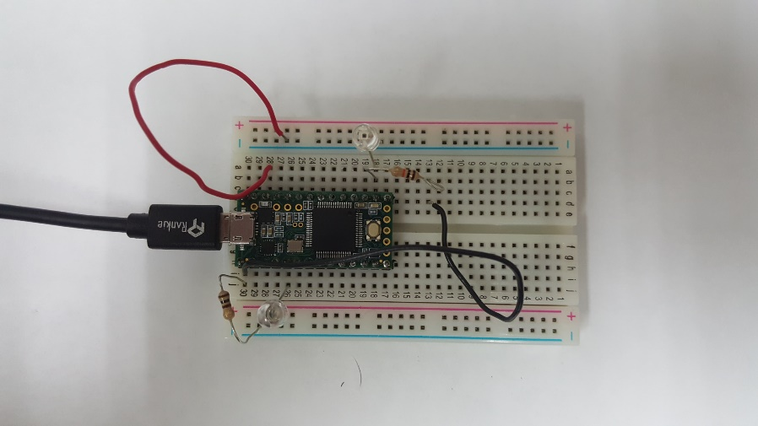
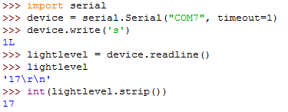
The led can be lit to 10 different brightness’s by sending the character ‘b’ immediately followed by a number 0-9.

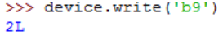
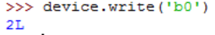
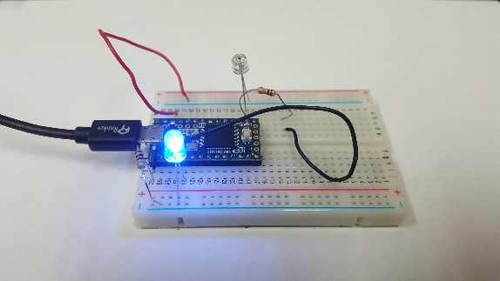
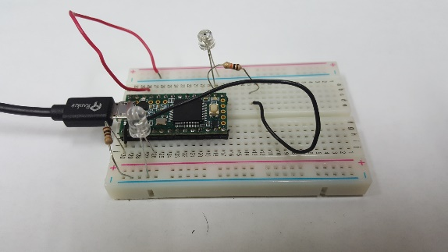

Table of Contents
What is MView? 1
The MView Interface 2
MView for Our Purposes 2
Setting up a simple GUI for LabRad Devices 2
Before You start: 2
Step 1: Imports 2
Step 2: Initialization 3
Step 3: Create a LabRad and Telecomm Server Connection 3
Step 4: Initializing Devices 3
A) Instantiating a new device 3
B) Adding Buttons 4
C) Adding Parameters 4
Step 5: Selecting the Device 5
Step 6: The Plot 5
Step 7: Begin() 5
Step 8: The Device List 5
Step 8: Starting MView 6
Step 9: Calling __init__() 6
Step 10: Putting it All Together 6
Devices in MView 8
MView Device Structure 8
The MDevice Class 8
Special fuctions 9
• MDevice.onLoad() 9
• MDevice.onBegin() 9
• MDevice.query() 9
• MDevice.prompt(button) 9
The MFrame Class 9
Writing a Device Driver 10
Things you should know 10
What it should do 10
How we will do it 10

